Issue 1:

Owning Organization attribute is not available in the Base 'Brazil RITA_Invetory_c' cube.

This is should be available as we do have only this cube used at several VI's

Issue 2:

Processing Activity Owner attribute is having both Blank and UNSPECIFIED. This will impact the Quality Metrics.

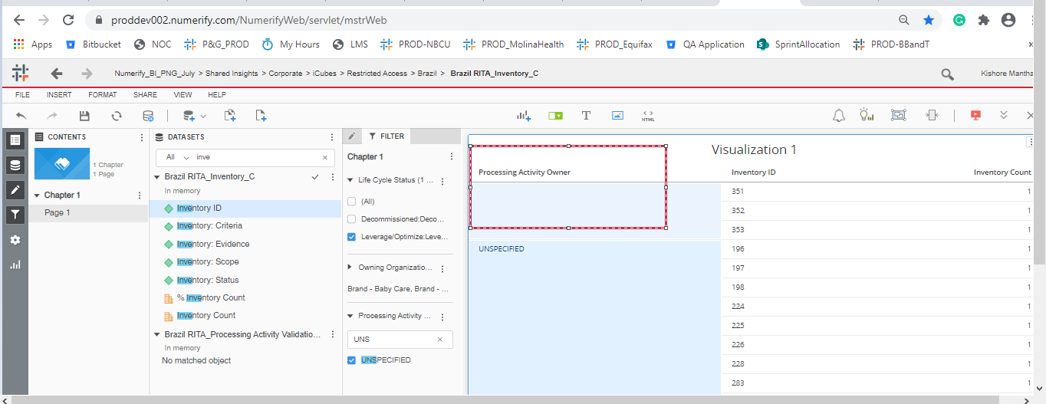

Issue 3: Retired Date is not as per the user requested

Should be DD-MM-YY HH:MM

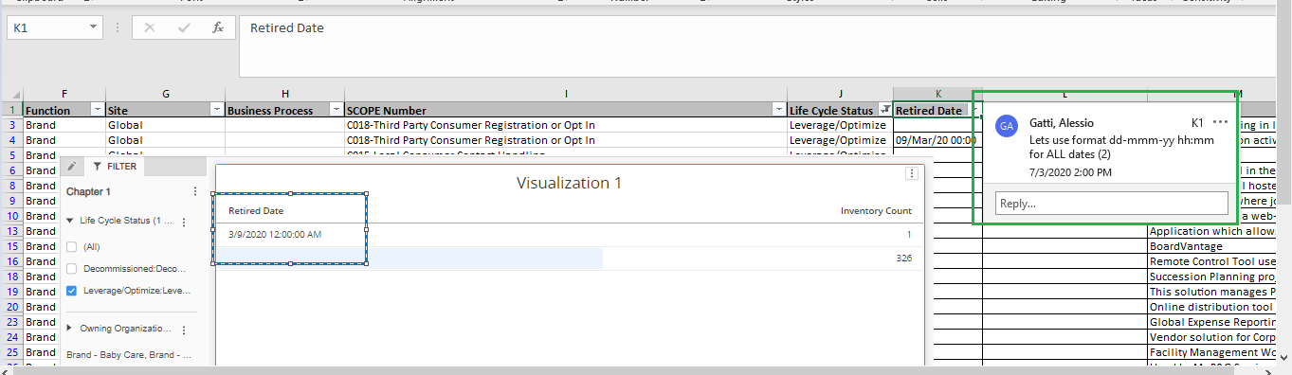

Issue 4: the data ‘Decommission Description’ is not matched with the ‘Decommission Details’

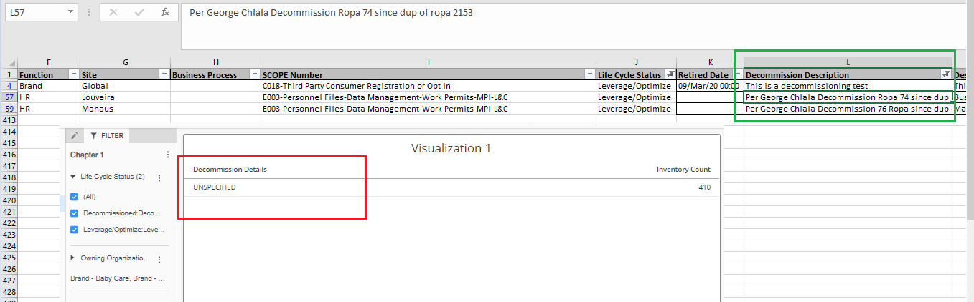

Issue 5: Creation Date is completely Blank.

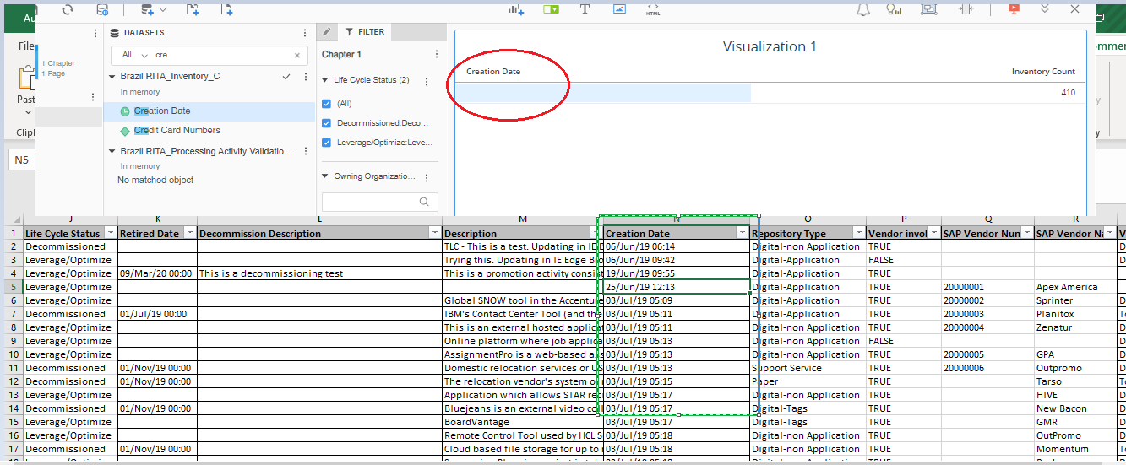

Issue 6: ‘SAP Vendor Number’ should not be a Float digit

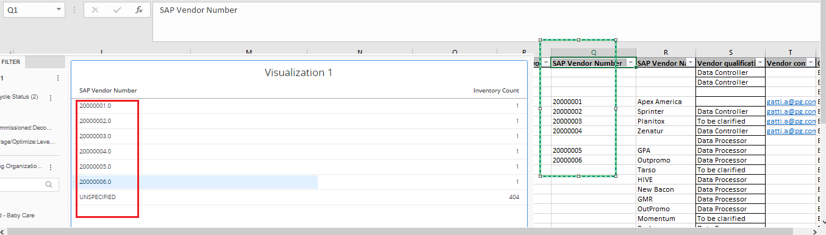

SAP vendor Name is also having the Blank : Ex: Inventory 1

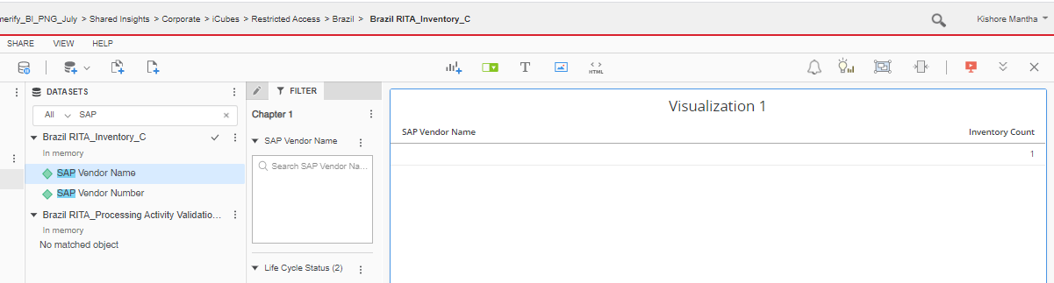

Issue 7: Inventory Scope should be always TRUE, irrespective of the compliance.

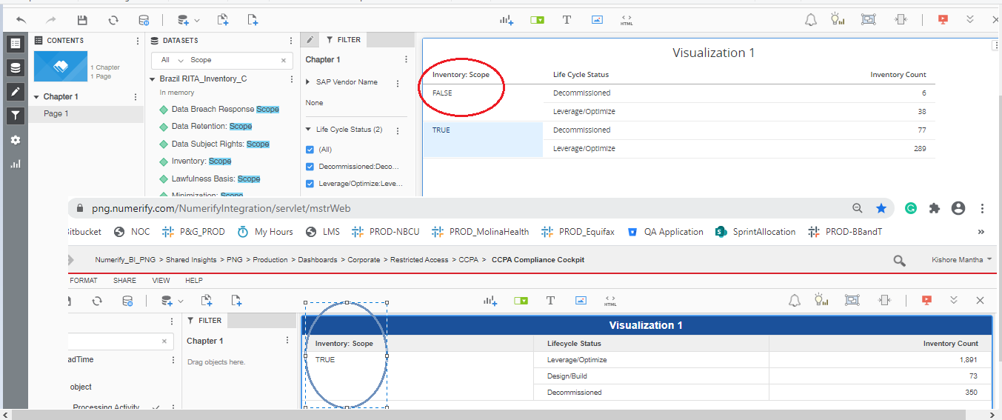

Issue 8: lawful Scope is not working as per the requirement.

1. Lawful Basics Scope Should be ‘FALSE’

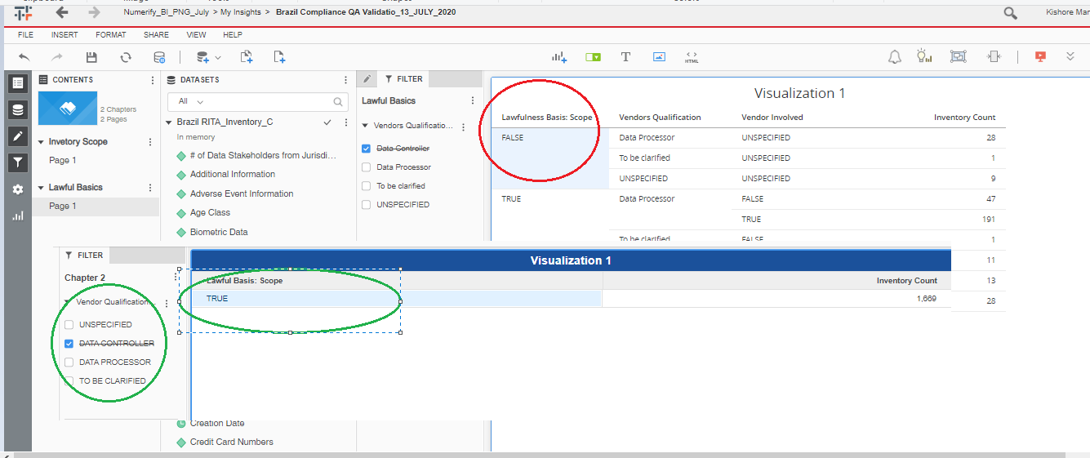

Notice Scope :

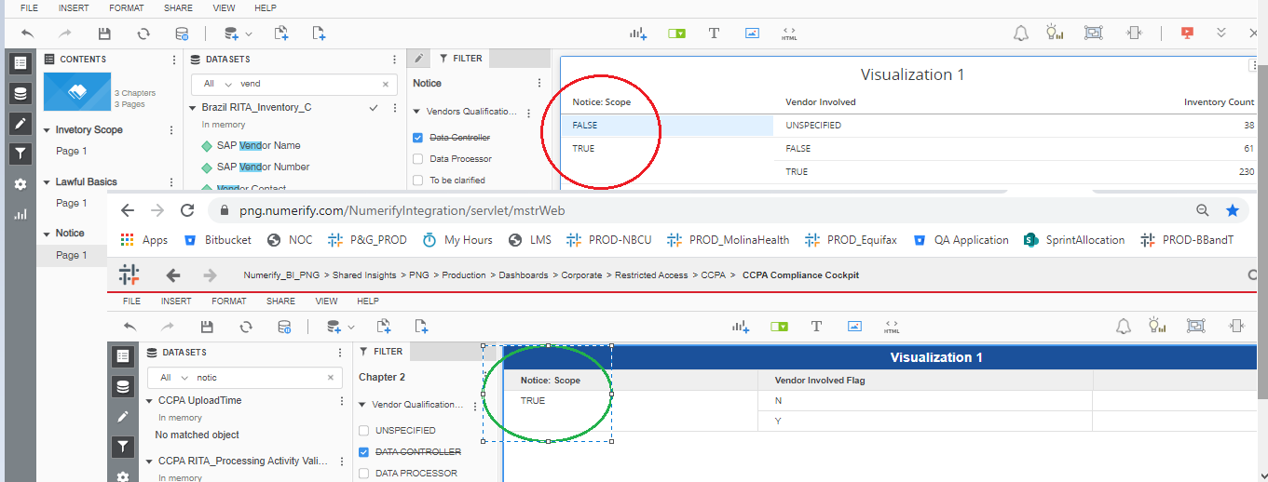

Minimization Scope :

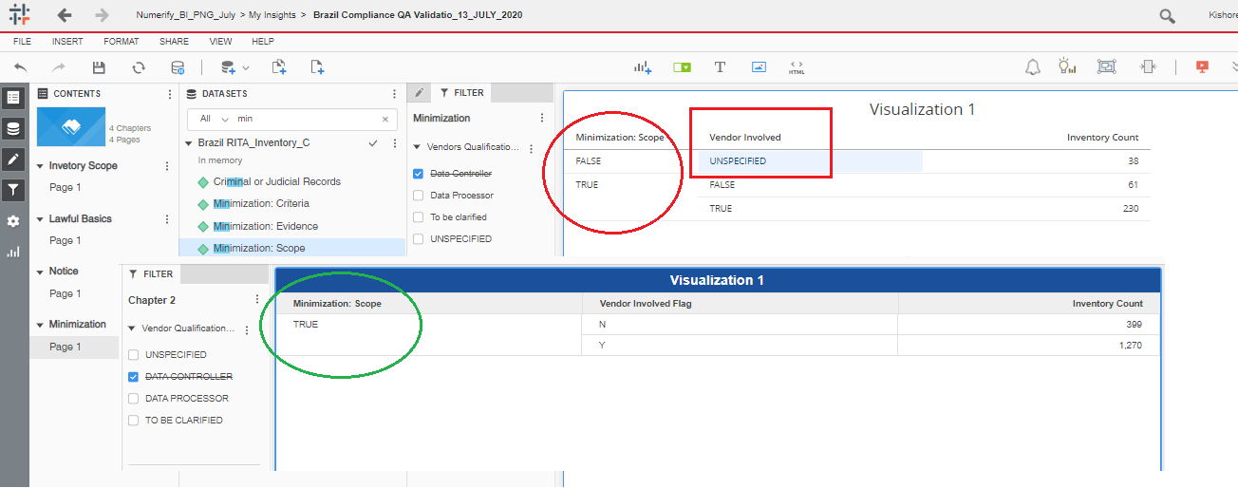

Data Retention Scope :

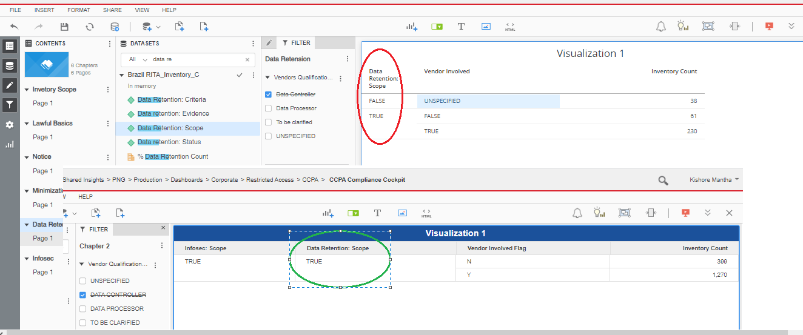

Infosec Scope :

